**Practical 4:**

**Objective: Finding roots of equations: False Position Method**

The false position method (or known as regula falsi) method is a term for problem-solving methods in arithmetic, algebra, and calculus. In simple terms, these methods begin by attempting to evaluate a problem using test ("false") values for the variables, and then adjust the values accordingly.

Most numerical equation-solving methods usually converge faster than Bisection. The price for that is that some of them can fail to converge at all, and all of them can sometimes converge much slower than Bisection—sometimes prohibitively slowly.

None can guarantee Bisection’s reliable and steady guaranteed convergence rate. Regula Falsi, like Bisection, always converges, usually considerably faster than Bisection—*but sometimes much slower than Bisection*.

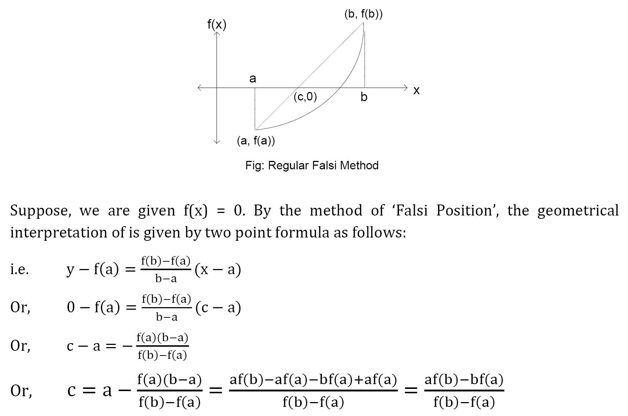

**Part A:**

Consider finding the root of $f(x) = x^{2} - 3$. Let εstep = 0.01, εabs = 0.01 and start with the interval [1, 2].

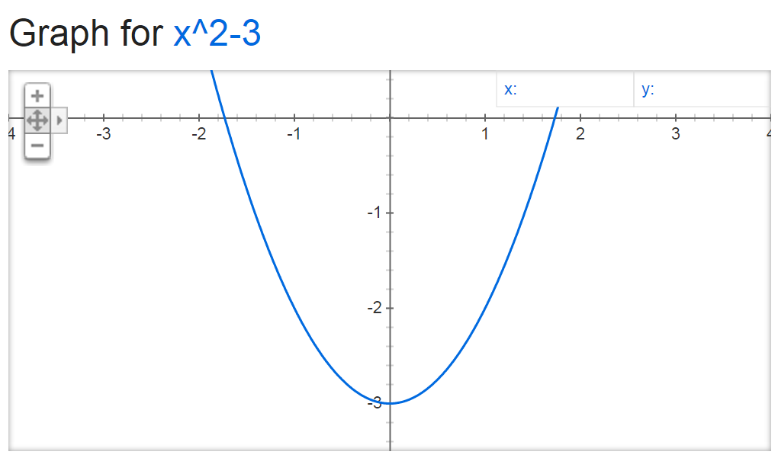

1. Write a program to compute $f(x)$ with false position method.

Output format:

|  |  |  |  |  |  |  |  |
| --- | --- | --- | --- | --- | --- | --- | --- |
| $$a$$ | $$b$$ | $$f(a)$$ | $$f(b)$$ | $$c$$ | $$f(c)$$ | **Update** | **Step Size** |
| **1** | **2** | **-2** | **1** | **1.66667** | **-0.22222** | **a=c** | **0.66667** |
| **1.66667** | **2** | **-0.22222** | **1** | **1.72727** | **-0.01653** | **a=c** | **0.06061** |
| **1.72727** | **2** | **-0.01653** | **1** | **1.73171** | **-0.00119** | **a=c** | **0.00443** |

1. What is your approximate of the root?

**Approximate Root of f(x) is 1.73171**

**Part B:**

Consider finding the root of $f(x) = e^{-x}(3.2 sin(x) - 0.5 cos(x))$ on the interval $[3, 4]$, this time with εstep  = 0.001, εabs = 0.001 .

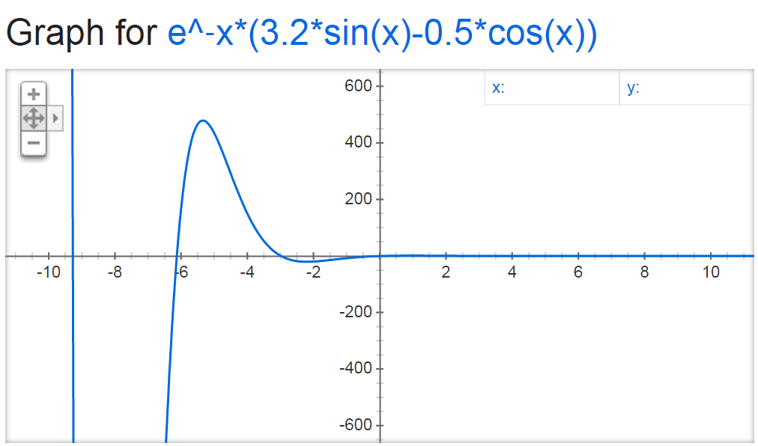

1. Write a program to compute $f(x)$ with false position method.

Output format:

|  |  |  |  |  |  |  |  |
| --- | --- | --- | --- | --- | --- | --- | --- |
| $$a$$ | $$b$$ | $$f(a)$$ | $$f(b)$$ | $$c$$ | $$f(c)$$ | **Update** | **Step Size** |
| **3** | **4** | **0.04713** | **-0.03837** | **3.55121** | **-0.02341** | **a=c** | **0.44879** |
| **3** | **3.55121** | **0.04713** | **-0.02341** | **3.36830** | **-0.00799** | **a=c** | **0.18291** |
| **3** | **3.36830** | **0.04713** | **-0.00799** | **3.31489** | **-0.00215** | **a=c** | **0.05341** |
| **3** | **3.31489** | **0.04713** | **-0.00215** | **3.30113** | **-0.00054** | **a=c** | **0.01376** |

1. What is your approximate of the root?

**Approximate Root of f(x) is 3.30113**

**Part C:**

Consider finding the root of $f\left(x\right)=xlog\left(x\right)-1$ which lies in between 2 and 3 correct to 3 decimal places using Regula Falsi Method.

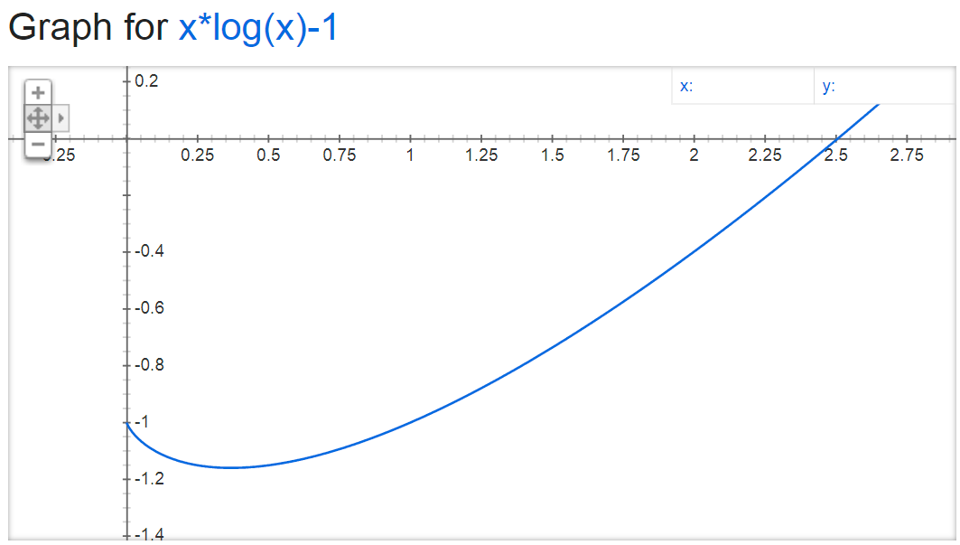

1. Write a program to compute $f(x)$.

Output format:

|  |  |  |  |  |  |  |
| --- | --- | --- | --- | --- | --- | --- |
| $$N$$ | $$a$$ | $$b$$ | $$f(a)$$ | $$f(b)$$ | $$c$$ | $$f(c)$$ |
| **1** | **2** | **3** | **-0.39794** | **0.43136** | **2.47985** | **-0.02189** |
| **2** | **2.47985** | **3** | **-0.02189** | **0.43136** | **2.50496** | **-0.00102** |
| **3** | **2.50496** | **3** | **-0.00102** | **0.43136** | **2.50613** | **-0.00005** |
| **4** | **2.50613** | **3** | **-0.00005** | **0.43136** | **2.50618** | **-0.00000** |

1. What is your approximate of the root?

**Approximate Root of f(x) is 2.50618**